Quantitative and Qualitative Decision-Making
Institution
Instructor

Name
Date
Table of Contents
Executive Summary 3
1. Payoff tables and decision tree. 4
2. EMVs for each alternative. 7
(1) EMV for not hiring a business analyst. 7
(2) EMV for hiring a business analyst. 7
(3) Final solution and recommendation. 8
After taking into consideration all necessary variables, the EMV 8
3. Sensitivity analysis. 8
4. The decision tree with payoffs, probabilities, and EMVs. 10
References 13
Tables 14
Figures 16

Executive Summary
The real estate company is considering to develop one of the following building projects: an apartment building, an office building and a warehouse. The company is faced with a decision whether to hire or not to hire a business analyst. To arrive analyze the various scenario, we used that ultimately lead to the construction of decision tree and calculate the EMVs for each alternative which gave a clear picture of every decision we were to take. We concluded that it was advantageous for the company to hire the business analyst and focus on the apartment building
Additionally, we also conduct sensitive analysis in Excel, a cross point appears, which further confirmed the need to hire the analyst. As a result, we strongly recommend that the outcomes of our analysis be implemented.

1. Payoff tables and decision tree.
Under this circumstance, the company is faced with a decision whether to engage a business analyst or not. Consequently, If the compony decide to hire, it will incur additional cost of 9000 as a survey fee
.
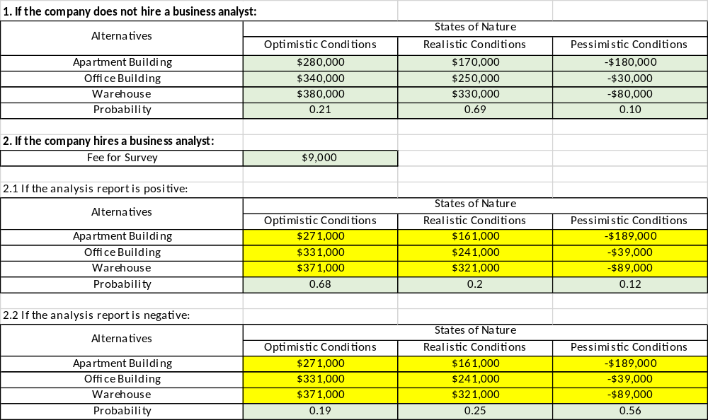

Table 1
The decision tree is as follows:

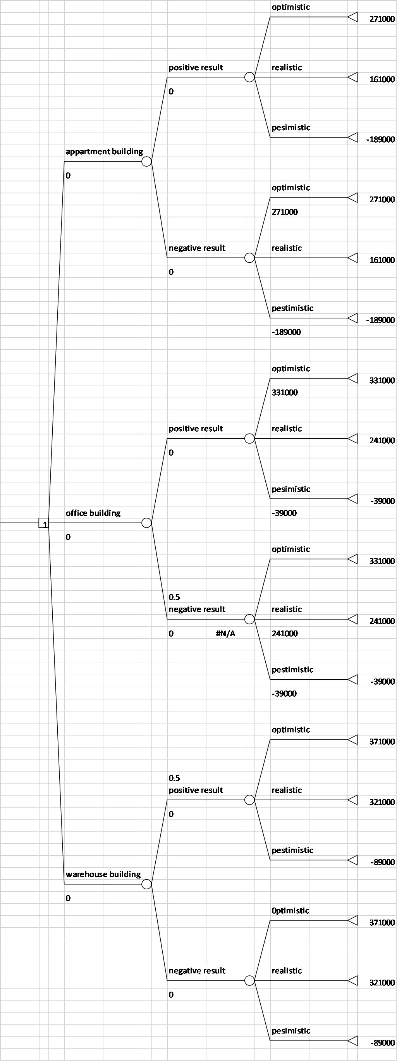Figure 1

2. EMVs for each alternative.
We Calculate the EMVs under the three given economic condition and the probabilities
(1) EMV for not hiring a business analyst.
If the company doesn’t hire a business analyst, the EMV for developing an apartment building is $158,100, the EMV for developing an office building is $ 240,900, the EMV for developing warehouse is $299500. The EMV for developing a warehouse is the highest, which means its favorable for developing
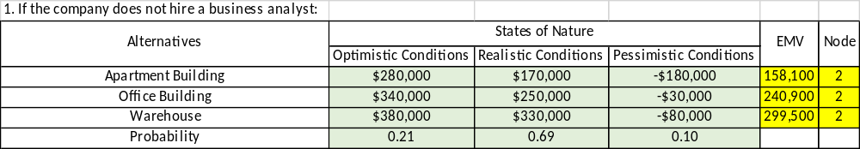

Table 2
(2) EMV for hiring a business analyst.
When the company opts to hire an analyst, the highest EMV for positive report results is $193800 which is from Apartment building whiles the corresponding highest EMV for the negative report is $101300 from office building. Conclusively, the EMV for hiring a business analysis is $152,900

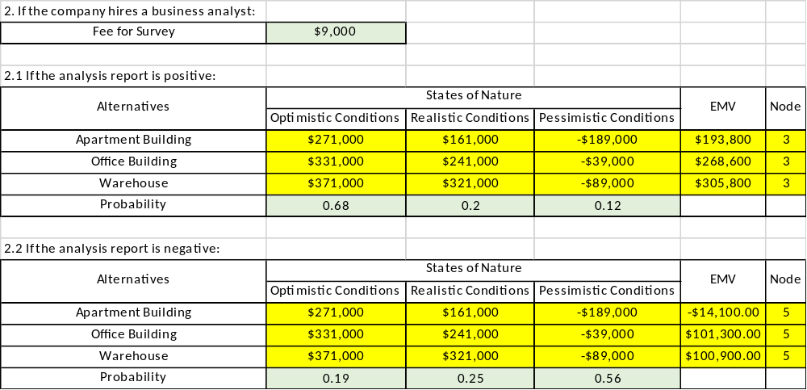

Table 3
(3) Final solution and recommendation.
After taking into consideration all necessary variables, the EMV for hiring an analyst is $152900 while its contrary side of not hiring is 50650. Consequently, hiring an analyst for apartment building is desirable
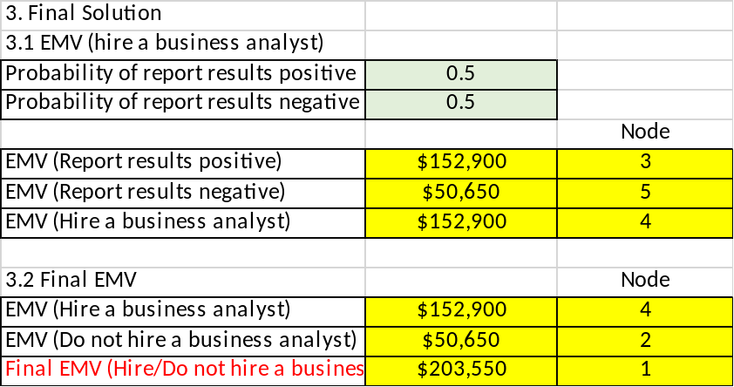

Table 4

3. Sensitivity analysis.
Assume that probability of positive report result is P, the probability of negative report result is 1-P, so:
$$EMV\left(hire an analyst\right)=P*EMV\left(positive\right)+\left(1-P\right)*EMV\left(negative\right)$$
Assume P equals 0.1, 0.2…1, the results of EMV for hiring an analyst are as follows:

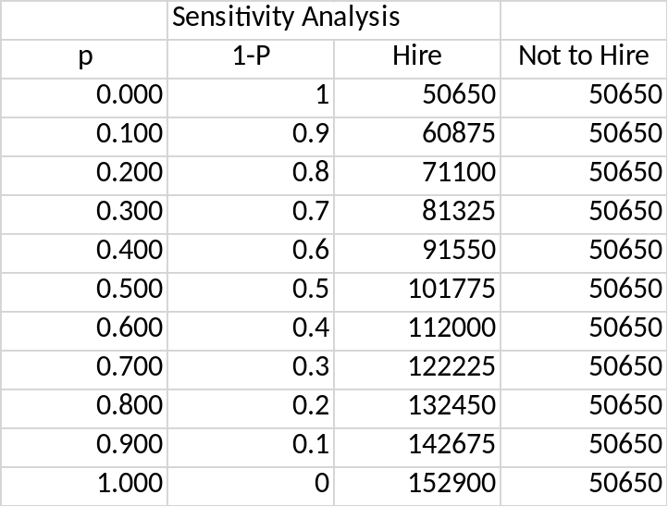

Table 5
Then we use line graph to show the trend of these two choices:

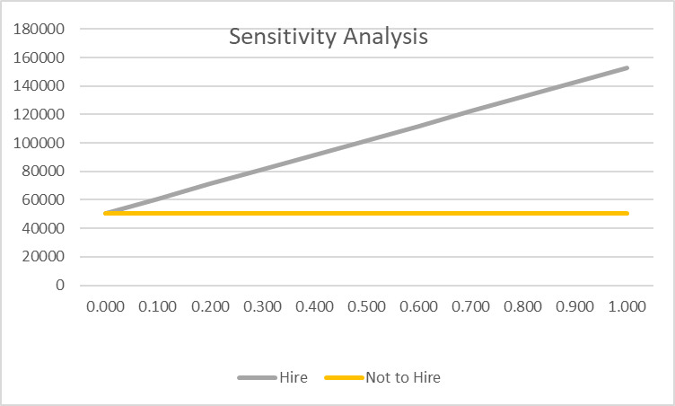

Figure 2
The blue line is obove the orange line which indicates that the EMV to hire is higher than EMV the corresponding not to hire values most of the time.
The cross point of the above graph is (0.001, 50650 which means that there is a zero probability not to hire the analyst which is favorable to the company.

4. The decision tree with payoffs, probabilities, and EMVs.
Excel is applied in constructing the decision tree. From this tree, the EMV for final decision is $341900 of developing an apartment and not hiring an analyst.
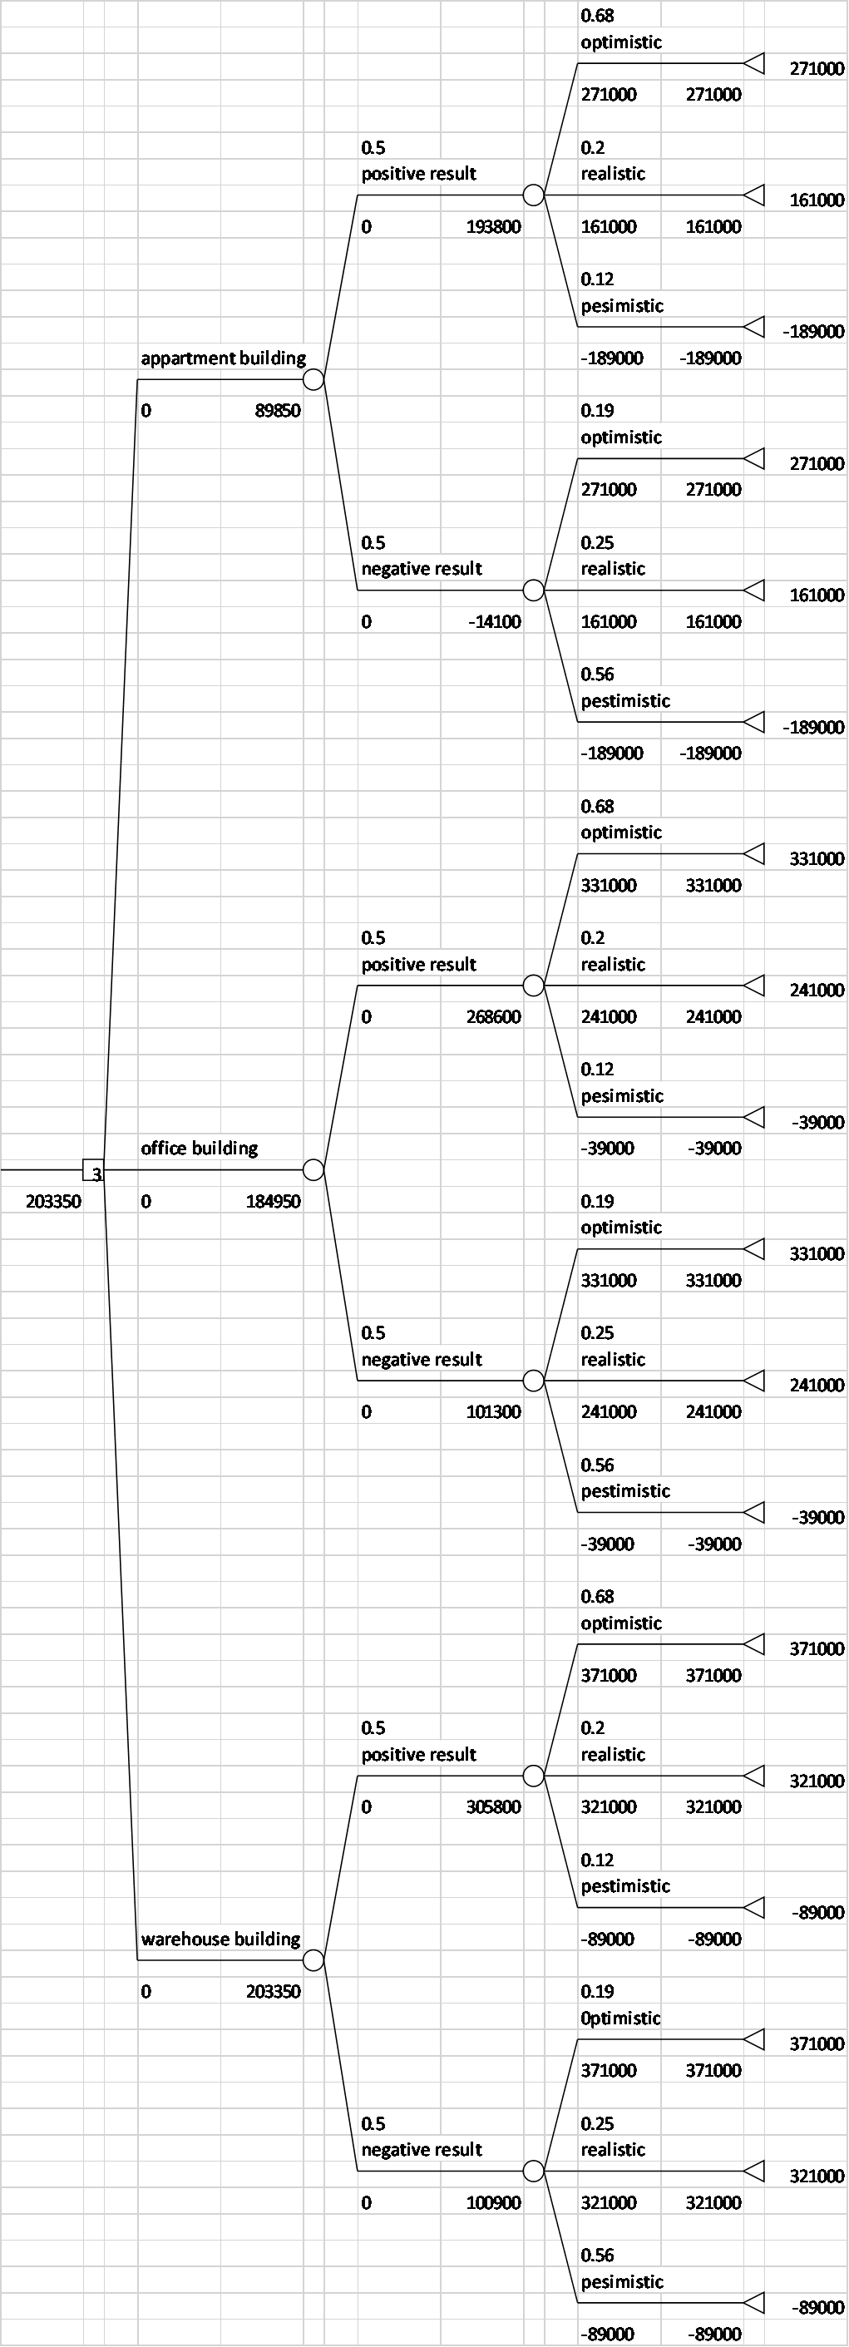
Figure 3

References
Worksheet in Excel file:
(i) A2 Text
(ii) Payoff Table - Template
(iii) Payoff Table - Solution and a sketch of a decision tree (without probability and EMVs)
(iv) EMV Calculation
(v) Sensitivity Analysis Diagram
(vi) Tree Plan Diagram of the Decision Tree

Tables
Table 1
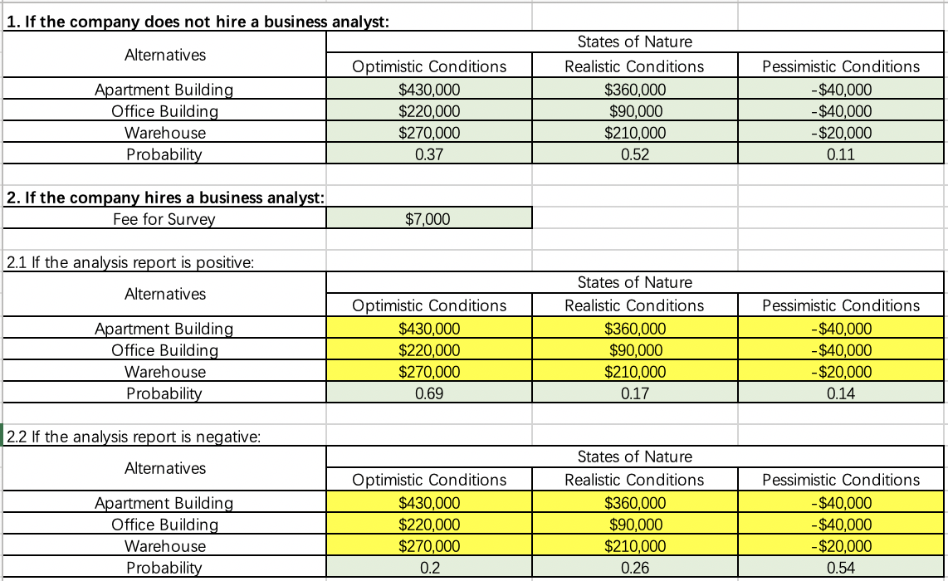
Table 2
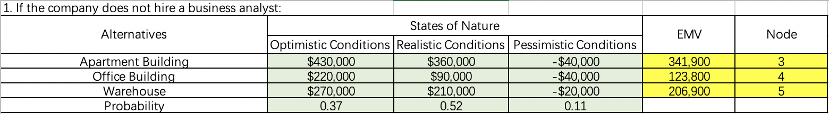
Table 3
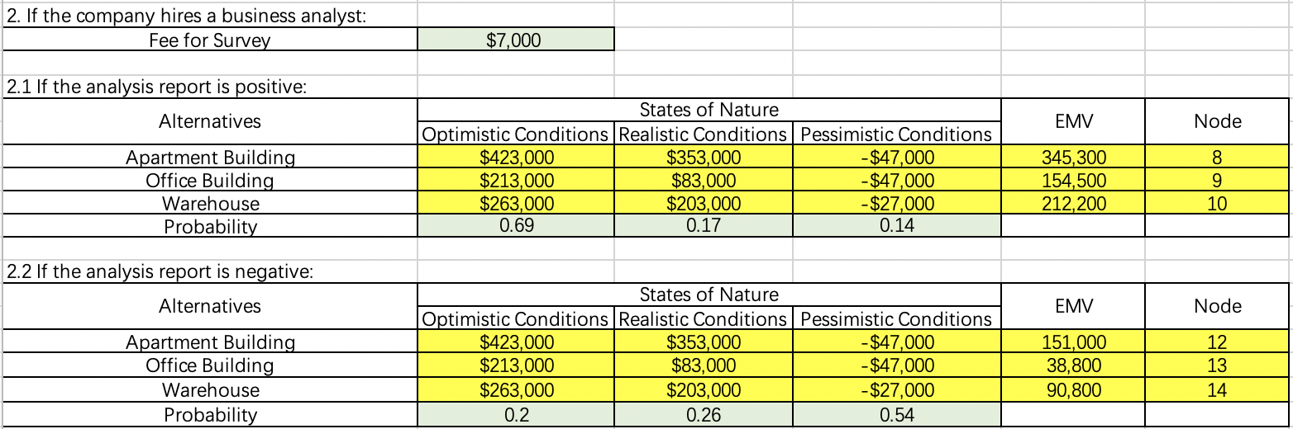
Table 4
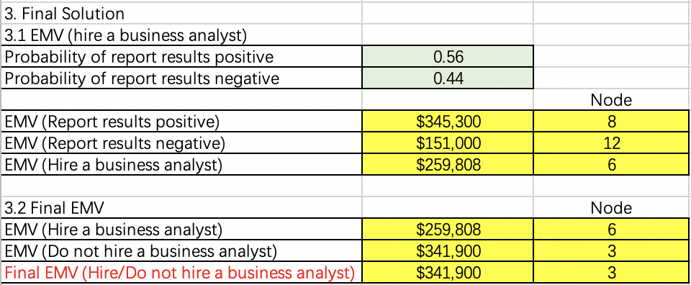
Table 5
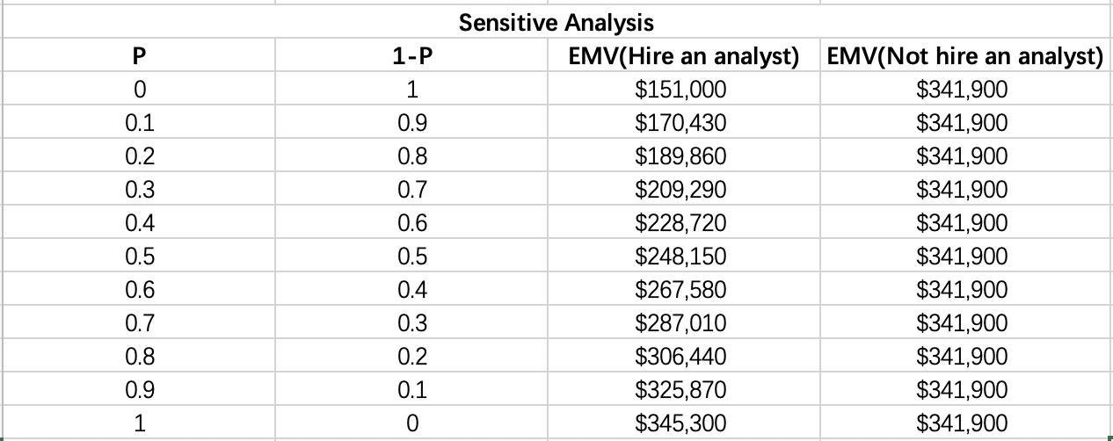

Figures
Figure 1.
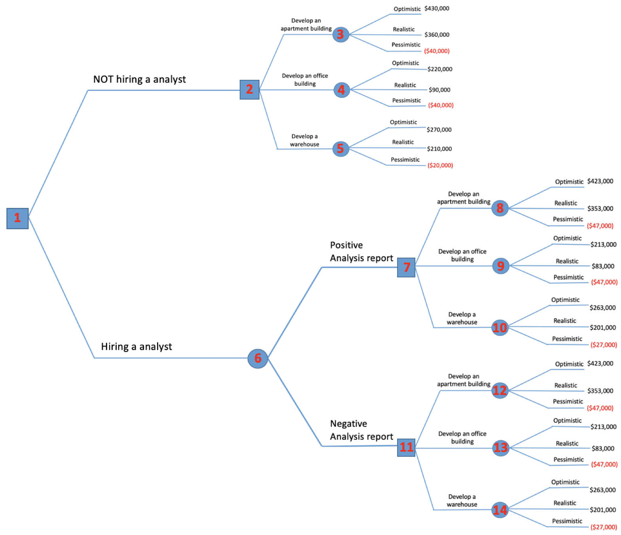
Figure 2.

Figure 3.
